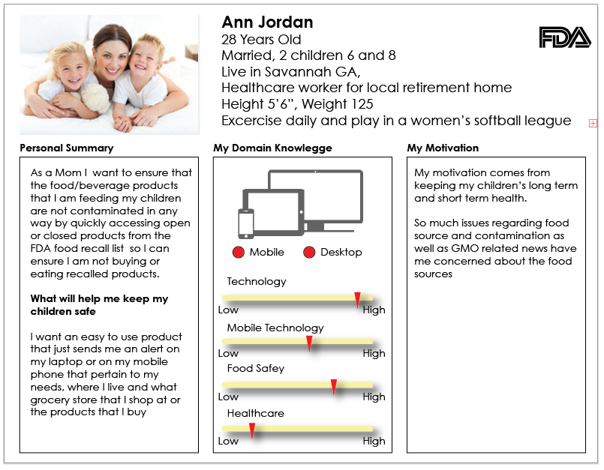

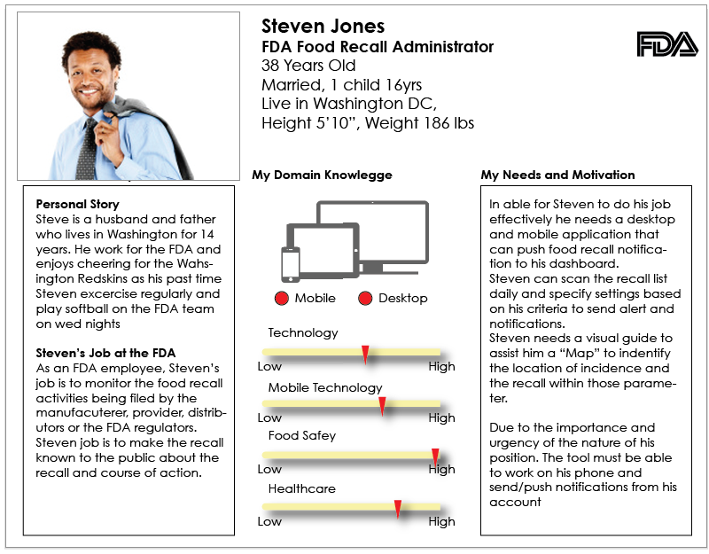 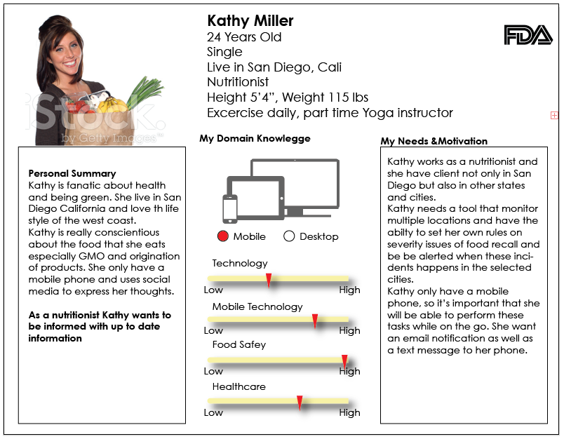

**Usability Testing Feedback and implementation**

Registration Modal:

User was confused previously if closing the modal means that the app will close as well. Verbiage have to be clear that shosing not to sign up does not mean that the user cannot use the app, their settings will not be available however.

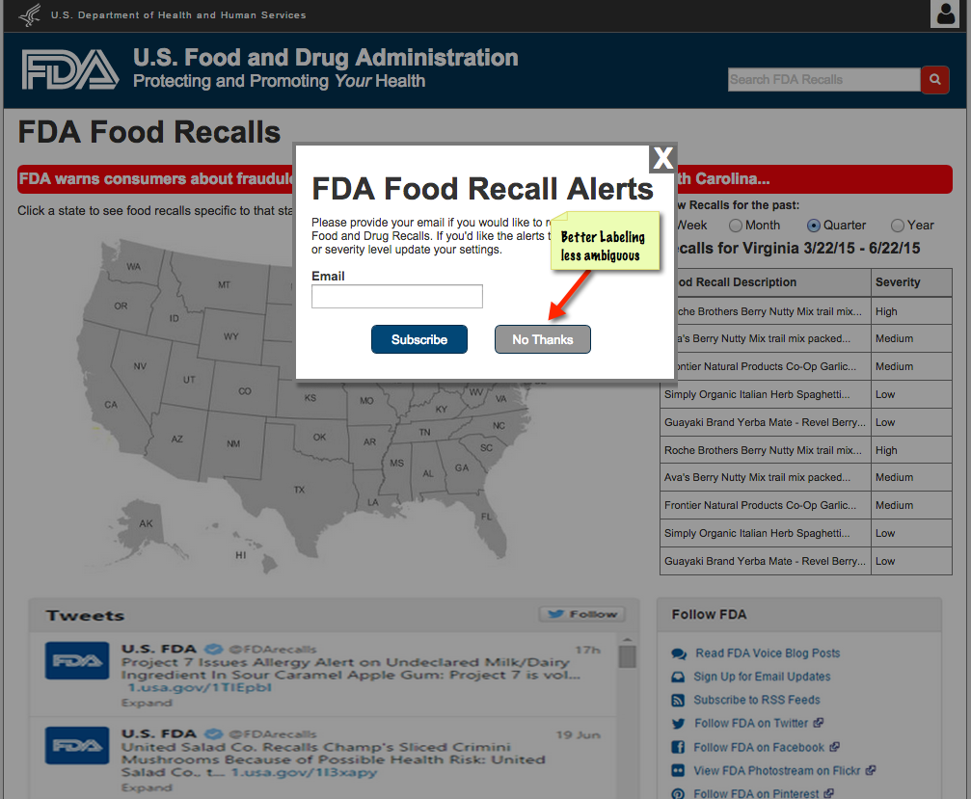

It was suggested by our user to make the recall list longer to access more information. Previous design show a short list UI.

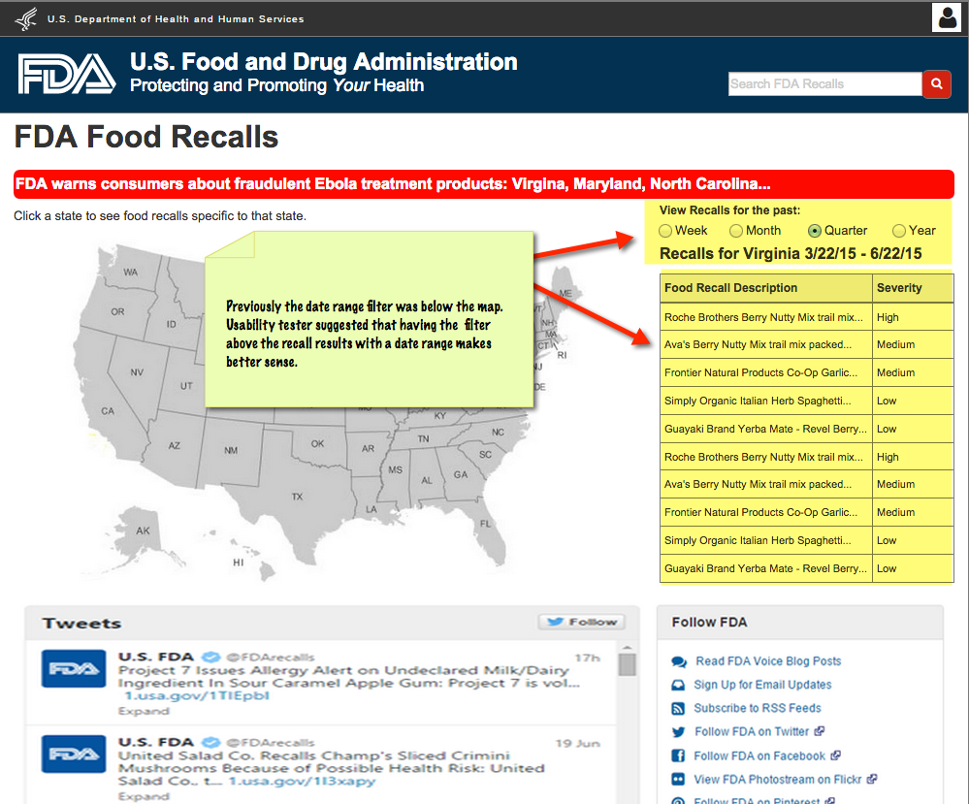

The lengthening of the recall list forces a design change to move the tweets and resources content blocks to the bottom,

